**Stats Krish Naik Day-3**

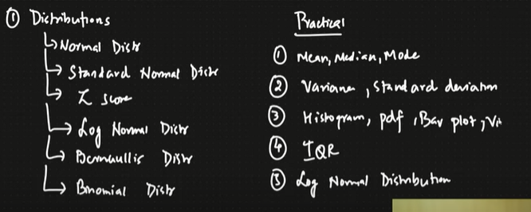 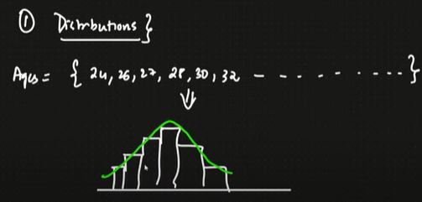

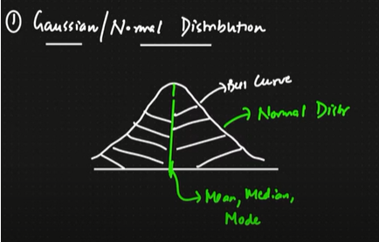

* Amount of colour Present on the both side of the mean/median/ mode are same

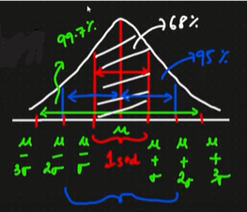

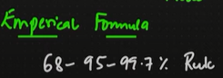 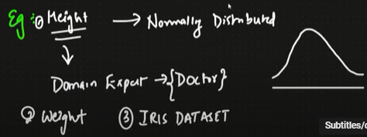

Normal Distribution

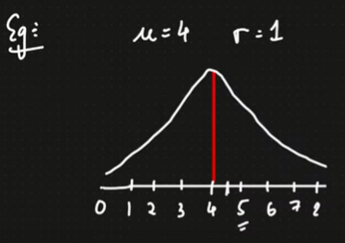

Z-SCORE

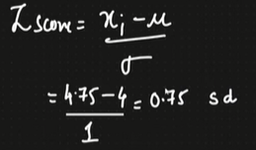

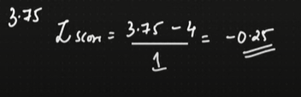

**Standard Normalisation distribution**

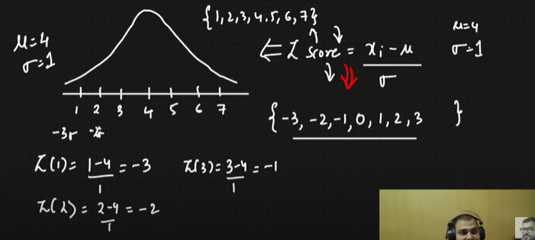

**Standardisation🡪(mean =0 and standard deviation = 1)**

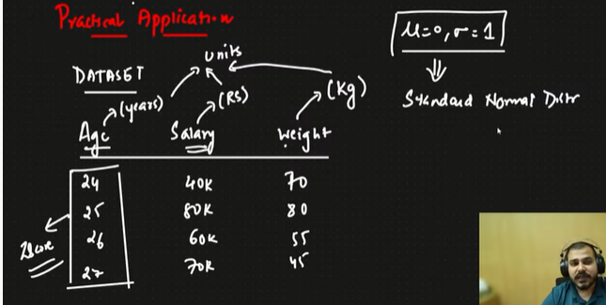

**Normalisation**

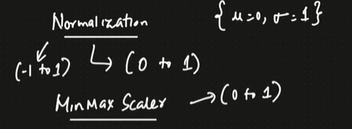

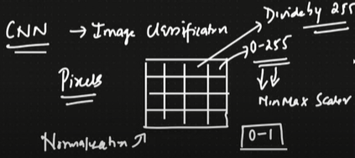

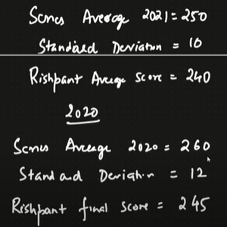

Compare in which series he performed better?? 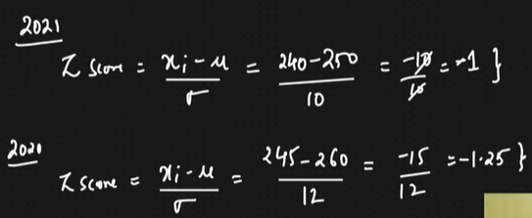

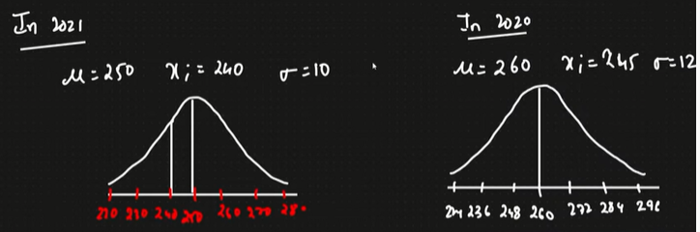

**In which one India performed well in final🡪**

**Seeing the standard deviation in 2021 India performed well as the standard deviation is lesser hence more score is concentrated**

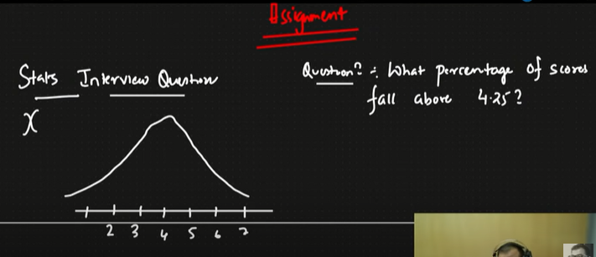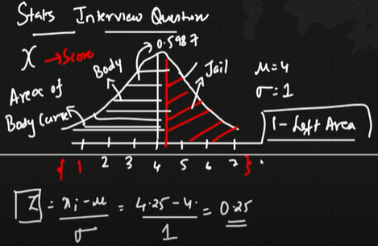

**Tail 🡪 What we require**

**Head 🡪 Part leaving tail**

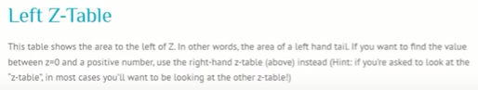

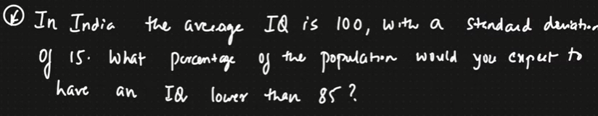

Z-Score = (85-100)/15

Right Table